**BLOCKCHAIN BASED NFT PLATFORM**

**A CAPSTONE PROJECT REPORT**

*Submitted in partial fulfillment of the*

*requirement for the award of the*

*Degree of*

**MASTER OF TECHNOLOGY**

**IN**

**INTEGRATED SOFTWARE ENGINEERING**

*by*

**AMIT KUMAR SAHU (18MIS7250)**

**SUNKARANAM VENKATA SURYA VAMSI (18MIS7211)**

**PAPUGANI VARSHINI (18MIS7035)**

*Under the Guidance of*

**DR. D. SUMATHI**



SCHOOL OF COMPUTER SCIENCE AND ENGINEERING

VIT-AP UNIVERSITY

AMARAVATI - 522237

*May 2022*

**CERTIFICATE**

This is to certify that the Capstone Project work entitled “**BLOCKCHAIN BASED NFT PLATFORM**” that is being submitted by **Amit Kumar Sahu (18MIS7250)** is in partial fulfillment of the requirements for the award of Master of Technology, is a record of bonafide work done under my guidance. The contents of this Project work, in full or in parts, have neither been taken from any other source nor have been submitted to any other Institute or University for award of any degree or diploma and the same is certified.

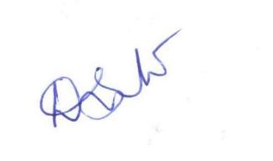

Dr. D. Sumathi

Guide

**The thesis is satisfactory**

**Approved by**

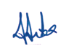

**PROGRAM CHAIR DEAN**

M. Tech. SE School Of Computer Science and Engineering

**ACKNOWLEDGEMENTS**

It is our pleasure to express with deep sense of gratitude to Dr. D. Sumathi, Associate Professor VIT - AP University, for her constant guidance, constructive feedback; more than all, she taught us that “where there's a will there's a way” by encouraging us with future application of the project.

We would like to express our gratitude to Dr. G. Viswanathan, G. V. Selvam, Kadhambari S. Viswanathan, Dr. D. Subhakar, and Dr. Hari Seetha, SCOPE, for providing us with an environment to work in and for their inspiration during the tenure of course.

We would also like to acknowledge with much appreciation and whole-hearted thanks to Dr. G. Viswanathan, Founder & Chancellor, VIT, all teaching staff and members working together in our university for their not-self-centered enthusiasm coupled with timely encouragement shown to us with zeal, which prompted the acquirement of the requisite knowledge to finalize our course study successfully.

Place: Amaravati

**ABSTRACT**

In this paper a secure and robust system is presented which can automatically trade the digital assets in a blockchain based platform and at the same time record every transaction in an immutable block. NFTs are provided in different forms like digital, art, sketch work, music and videos. NFTs popularity has been increasing day by day which crossed $40 billion revenue in 2021 NFT market report which was finalized by blockchain data company chainalysis. Some of the most used nft marketplace to sell and buy our digital assets are Opensea, Rarible, NBA Top Shot. Opensea is the largest nft marketplace with ancient and well organized nft standards that was launched in 2017 which is active today. The main cryptocurrencies used in opensea are ethereum, Solana and USDC. We cannot use normal currencies like rupees, dollars, euros. Marketplace can be used by any kind of people. We can create account easily and start searching for our new nft business. Opensea marketplace charges 2.5% of every single transaction. We must also need to pay tax gas fee for finishing NFT transactions with Ethereum.Opensea is best choice for starters.when it comes rarible allows users to trade art collections,video games and huge number of nfts.Even rarible charges 2.5% tax fee on every transaction we made on it.But best feature in rarible is we can also made payments using our credit cards and fiat currencies.

NFT marketplace will handle different transfer of exchange fees from one party to other.The working of nft marketplace is user need to create his own account and then install specified digital wallet, to store his/her nfts. Users can also create their assets by uploading items to publish their work. After that they can select their payment way and next step is to list items for sale. The users who select bidding process for a fixed price or auction way of selling his nft or buying also follows same procedure. A transaction is created when shortlisted an item for trade and will launch smart contract for users wallet.

Ethereum is most popular nft marketplace now a days because transaction data and meta data is flexibly verifiable on ethereum, so it was easy to publish ownership. Ethereum never goes down so nfts are always on for sale. Some of the major nft standards are ERC-721, ERC-1155, FA2 AND TRC-721.frontend frameworks used are react,angular and vue.Minting an nft means just converting a digital folder into a blockchain based nft.nfts provide many ways to make money either by renting your nft,gaining royalty on them, staking our nft and even by flipping your nft.Flipping basically means buying an nft on a specified marketplace and trading it for higher price.But experts suggests to buy only nfts having some inherent value.cryptos,nft and other virtual digital assets are still not well used assets in india because investing in them may cause losses.

**TABLE OF CONTENTS**

**CHAPTER 1** 6

**INTRODUCTION** 6

**1.1 BACKGROUND AND LITERATURE SURVEY** 7

**1.2 PROBLEM DEFINITION** 8

**1.3 OBJECTIVES** 8

**1.4 SCOPE OF THE PROJECT** 8

**CHAPTER - 2** 10

**METHODOLOGY** 10

**2.1 TECHNOLOGY USED** 10

**2.2 PROPOSED METHOD** 11

**2.3 WORKFLOW** 12

**2.4 UML DIAGRAMS** 13

**CHAPTER - 3** 20

**CONCLUSION** 20

**3.1 TESTING SMART CONTRACT** 20

**3.2 DEPLOYING TO LOCAL NODE** 20

**3.3 DEPLOYING SMART CONTRACT** 21

**3.4 STARTING THE DEVELOPMENT SERVER** 21

**3.4.1 Home page** 22

**3.4.2 Importing accounts to meta mask wallet** 22

**3.4.3 Uploading asset** 22

**3.4.4 Buying asset** 26

**3.4.5 Creator dashboard** 27

**3.6 REFERENCES** 30

## **CHAPTER 1**

### **INTRODUCTION**

Before the introduction of NFTs the value of digital art was very cheap compared to the price that people are now selling on blockchain platforms. Can be anything digital, such as a piece of art or drawings or music. NFTs can represent real-world items like artwork. “Tokenizing” these real world tangible assets makes the process of buying, selling and trading more efficient along with reducing the probability of frauds.

Non Fungible Tokens (NFTs) have been a booming technology that is enhancing the authenticity, safety, integrity and privacy of the users. Since the year 2021, NFTs have started hyping out with a huge marketplace. The digital art creators were finally able to sell their piece of digital art without middlemen. Blockchain is a promising technology which is widely known for it’s immutability, privacy and protection of users. The most important part of this marketplace is the use of smart contracts, which can be altered as per the need of the seller.

### **1.1 BACKGROUND AND LITERATURE SURVEY**

In 2021-28.4 thousand and in this year over 22.6 thousand NFTs were sold. NFT transactions on the popular marketplaces with the peak trading days on April and May of 2021 was between 1,000 and 3,000 unique wallets buying NFTs. Till now around 2.4 million NFTs sold on OpenSea, which the largest NFT marketplace. NFTs are becoming some of the most profitable blockchain-based applications in history. High-profile influencers like Twitter CEO Jack Dorsey, have recently made the news by auctioning off expensive NFTs. Based on its current growth rate, reputable sources forecasted that the NFT market will grow about $80 billion by 2025. The following figure shows the expected growth.

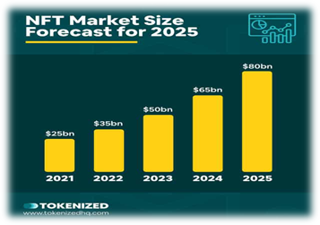

Total sales coming out to $91.8 million, it makes *The Merge* the most expensive NFT sale by a mile.

### **1.2 PROBLEM DEFINITION**

* Lack of existing platforms that would credit or give ownership to the real/genuine owner of the digital asset.
* Either the digital assets are copied, or are sold in other platforms without authenticity or sense of ownership, which leads to duplicate assets.
* Identity theft and hacking has been around for several years and thus in need of a platform which is resistant from these.
* User’s selling digital assets and later falsifying statements that they didn’t buy/sell the digital asset.

### 

### **1.3 OBJECTIVES**

* The main aim of the project is to build an open digital economy with a new type of digital goods called Non-fungible tokens and create a marketplace where we can sell and buy digital art.
* With the concept of unique cryptographic tokens we will create application that will enrich secure transaction without frauds.
* People are excited about a brand new type of digital goods called non-fungible tokens or NFTs. Hence a lot of investors are looking for blockchain-based appications.
* It wouldn’t probably make a lot of sense to build an application where you’re trading in assets that are two to ten dollars on ethereum because the transaction itself costs more than that and transactions per second are slow but working on scalable solutions like polygon transaction fee is lesser and faster.

### **1.4 SCOPE OF THE PROJECT**

The main Scope of building nft based blockchain marketplace is nft tokens are government issued digital currencies and are used for many in-app purchases in many gaming applications all over the world.

We can alot from the blockchain usage in future which will be expanding alot.Its safe to assume that the nft market will continue to grow then it may totally change the currency system.

Real estate is major asset class in which most money is being invested.NFT can employed in real estate in several ways.Example we can place the ownership of piece of our land or property on a particular blockchain and allow others to see it.

Just like artwork or memorabilia in classic traditional sense,some NFT collections can be appreciate in value while others will be forgotten easily.

NFT marketplace enables users to buy,sell and trade their unique nfts legally in most seamless manner with most common digital currencies like ethereum.

## **CHAPTER - 2**

## **METHODOLOGY**

### **2.1 TECHNOLOGY USED**

◦ Polygon Network (Blockchain Network)

◦ Next.js (Backend framework)

◦ HTML & CSS

◦ Solidity (Blockchain based programming language)

◦ IPFS (InterPlanetary File System)

◦ Ethers.js (Interact with Ethereum blockchain)

◦ Hardhat (Smart contracts simulation)

◦ Google Chrome/ Mozilla / Safari / Brave (METAMASK Plugin)

### **2.2 PROPOSED METHOD**

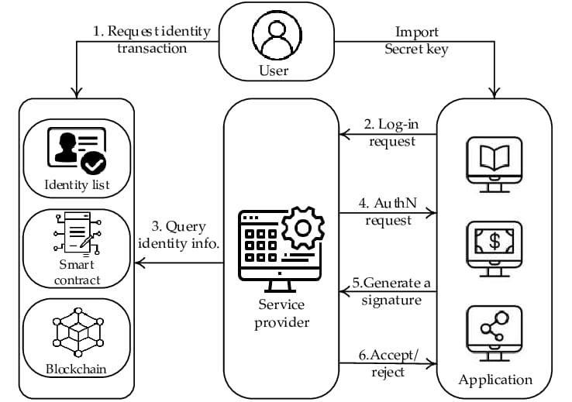

The main two processes included in proposed model is registration and login

**Registration:** In registration we first initialize the user’s public key as their identifier key which is the username. The next step is uploading the identity key created on our blockchain, in which transactions made can be validated by other external users. Later the user can generate an identity transaction.

**Login**: After registration, the user will login to the system and the procedure is as follows:

1)In the first step, the user uses identity information and transfer their secret key into the service application for login.

2)A user who needs to log in sends a login request to the main network service provider, in our case it’s the polygon network.

3)The service provider verifies the login request, then extracts the main hash (sometimes the term “nonce” is used), then queries with the blockchain network, and finally retrieves the identity information from an identity list.

4)The network’s service provider responds with the authentication request from the polygon network, when the total above mentioned process is accomplished. A timestamp, username and signature will be included in authentication request.

5)User creates a unique signature with mainly five parameters: timestamp, username, public key and username and public key of the service provider. Here user authentication is used as signature.

6)The network’s service provider verifies the received information and if the information received is valid or not, the authentication succeeds.

7)If the above process is not carried out properly, the authentication fails and users login is denied

### **2.3 WORKFLOW**

* Create a piece of digital art which in terms of our context is known as NFT (Non Fungible Tokens), basically the unique nft will be associated with the digital art work. The process of converting your digital art to NFT is known as mining. NFTs are mined once they are created.
* The second step is to create a META MASK wallet. So basically it’s a plugin which is available only on your browser store. Following are the steps to create a META MASK wallet.

1. Download the extension and add from here <https://metamask.io/>
2. Click on the meta mask wallet extension and click on get started button.
3. Create a wallet and set a strong password for it.
4. Then securely store the seed phrase for your metamask wallet.
5. Confirm your secret phase for opening a meta mask wallet.
6. Finally now you are ready with your new meta mask wallet.

* Login and authenticate to our application by giving permission to your META MASK wallet. A pop will come from your browser extension and it’s up to the user whether they want to give permission.
* Upload your digital asset to the website and provide metadata for the same. Confirm the contract and pay the gas fee to list your item for sale. (Amt will be deducted from your metamask account)
* Now the NFT is ready for sale in the marketplace. The buyer will login to his/her metamask wallet and buy the NFT by clicking on the buy button. The buyer needs to confirm the smart contract. After the confirmation the respective amount will be deducted from the buyer’s account and finally the amount will be added to the seller’s account.

### **2.4 UML DIAGRAMS**

**SEQUENCE DIAGRAMS:**

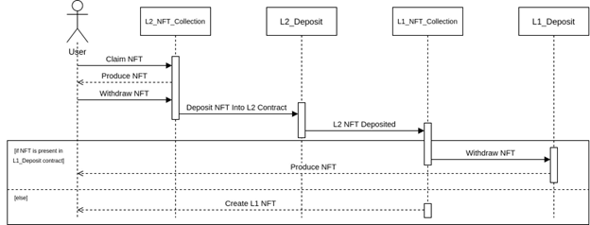

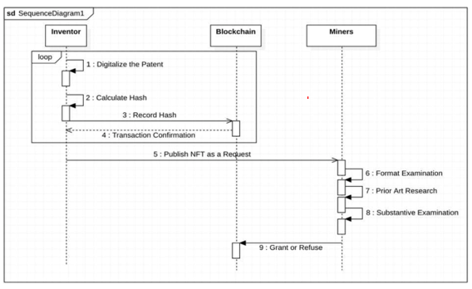

**CLASS DIAGRAM:**

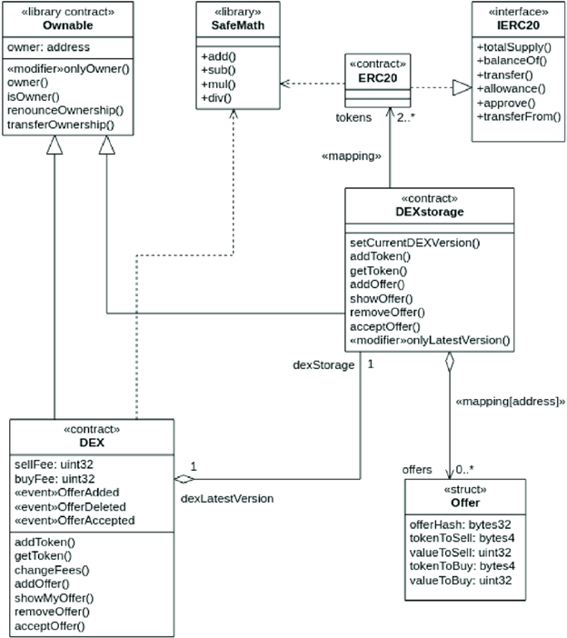

**OBJECT DIAGRAMS:**

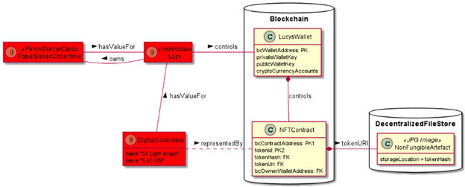

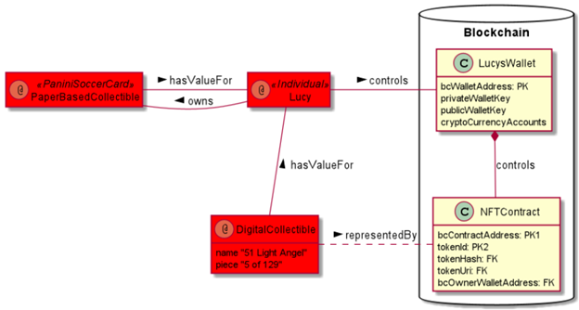

**WORKING AS NFT DEVELOPER:**

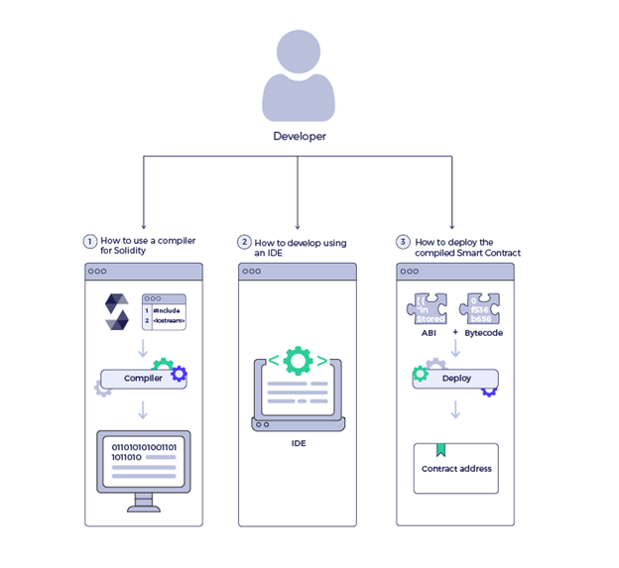

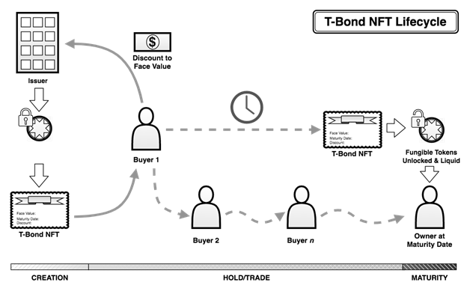

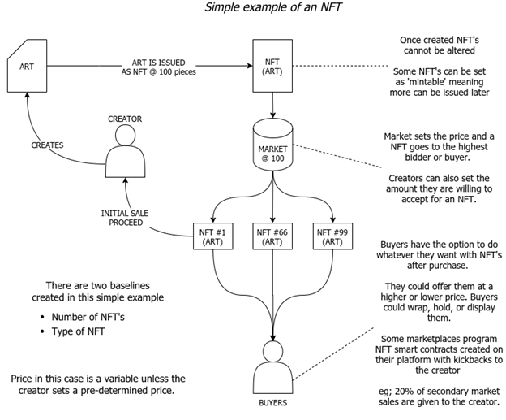

## **CHAPTER - 3**

## **CONCLUSION**

### **3.1 TESTING SMART CONTRACT**

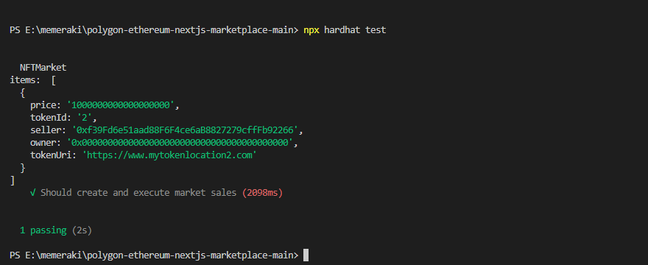

Testing the smart contract.From here we can say that the smart contract is working properly and transactions will be working fine.

## 

### **3.2 DEPLOYING TO LOCAL NODE**

Deploying to local node - hardhat environment

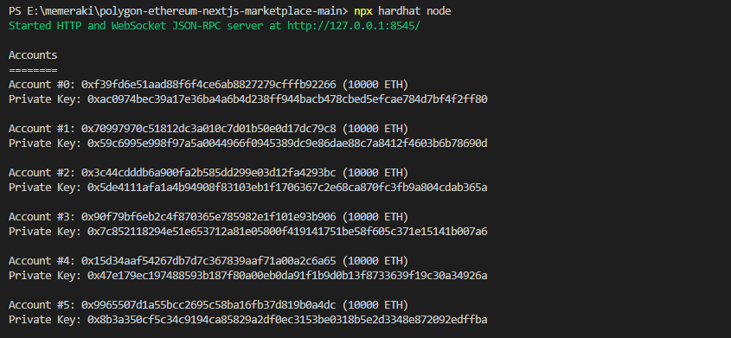

This will create 20 dummy accounts to test the application. Each account will have 1000 Ethers.

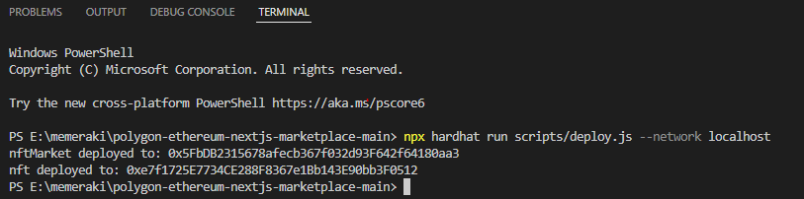

### **3.3 DEPLOYING SMART CONTRACT**

Deploying smart contracts. Parallelly on other terminal we will deploy our smart contract. The address of the nftMarket and nft we will copy and add it to our configuration file.

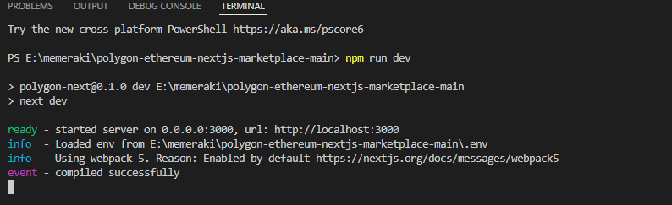

### **3.4 STARTING THE DEVELOPMENT SERVER**

Parallelly in another terminal we will run the development server

Accessing the application through browser (localhost:3000)

#### **3.4.1 Home page**

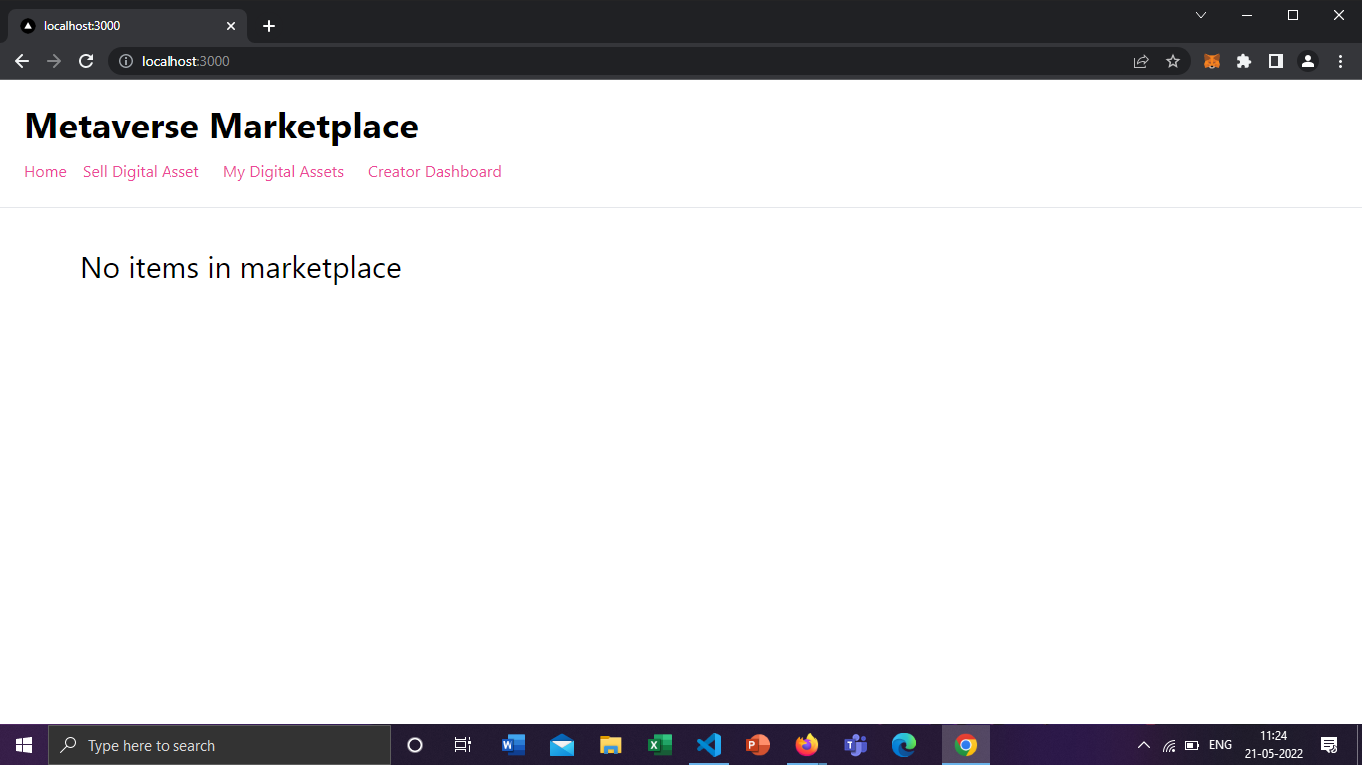

#### **3.4.2 Importing accounts to meta mask wallet**

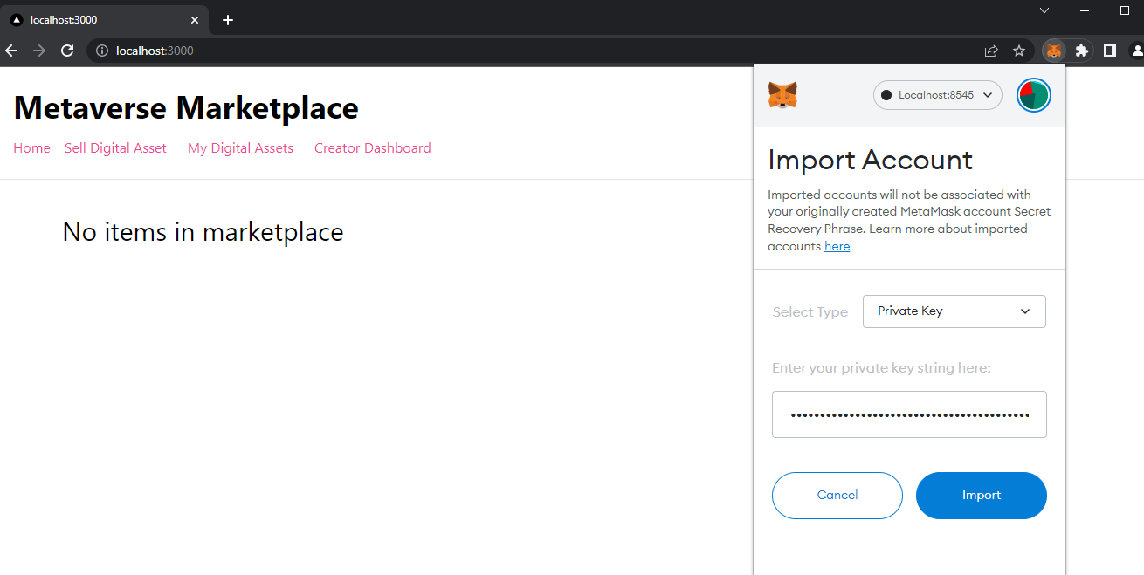

#### **3.4.3 Uploading asset**

We will switch to account 4 and upload the digital art

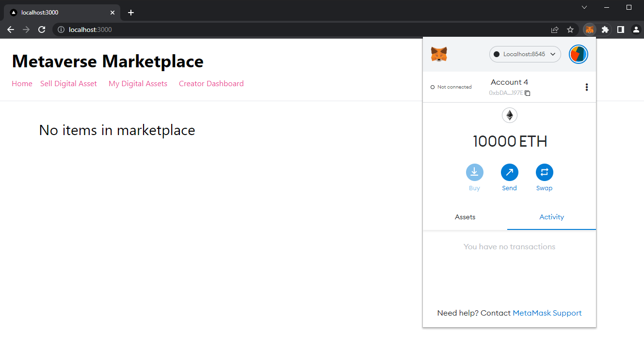

Click on sell digital assets

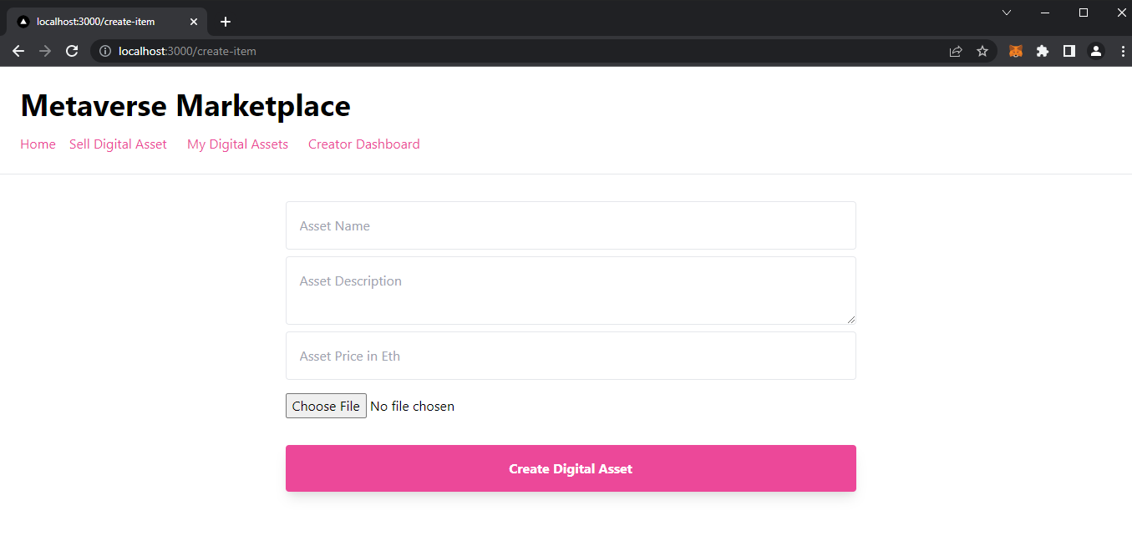

Give contract permission to pay gas fees and upload the digital art into the market place.

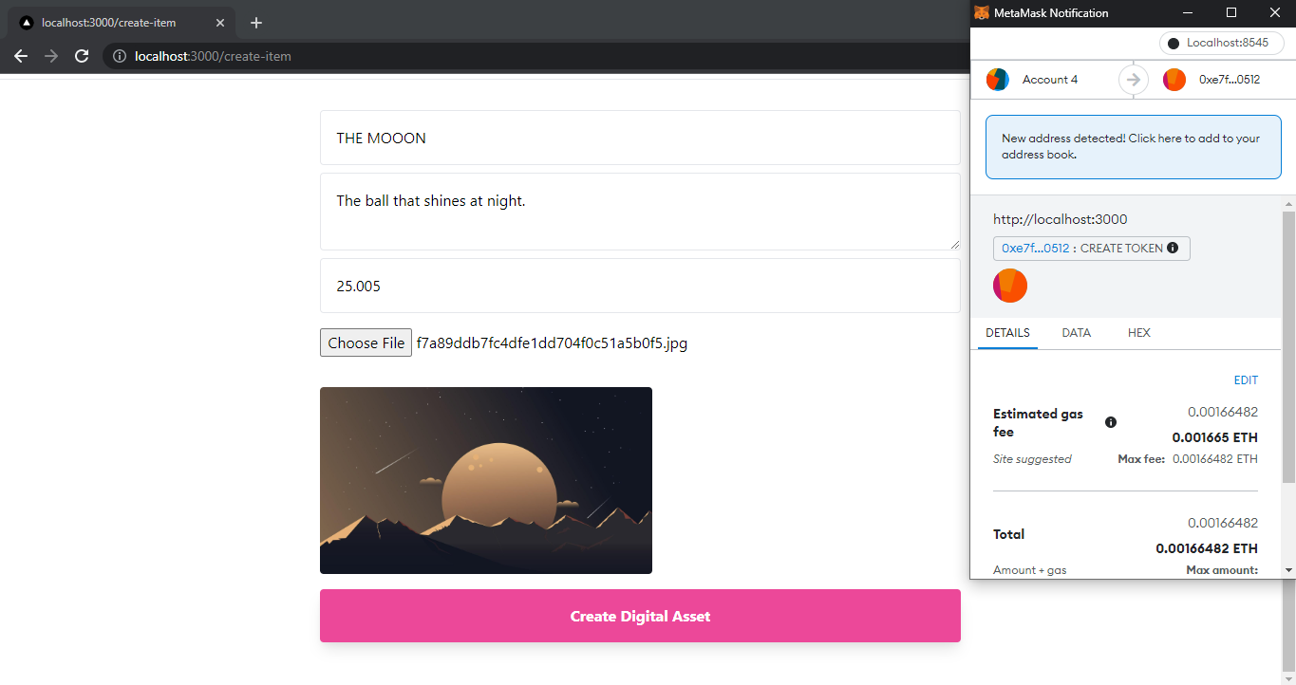

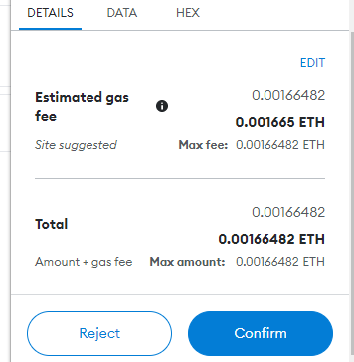

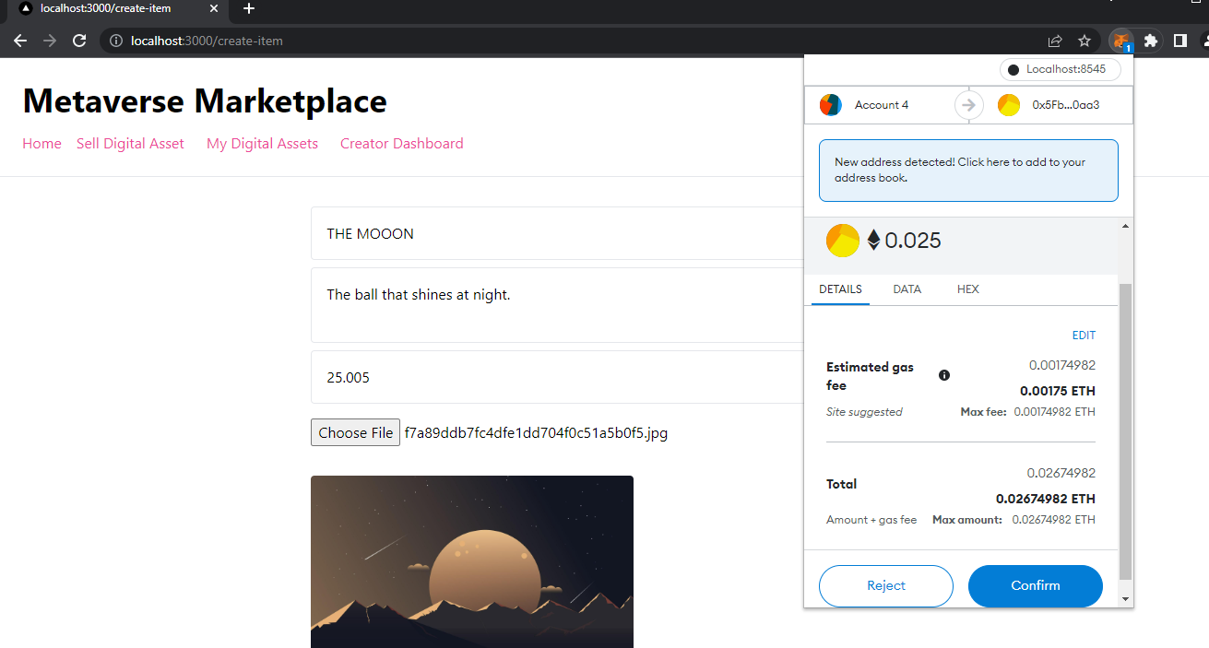

The amount will be deducted from your META MASK wallet.

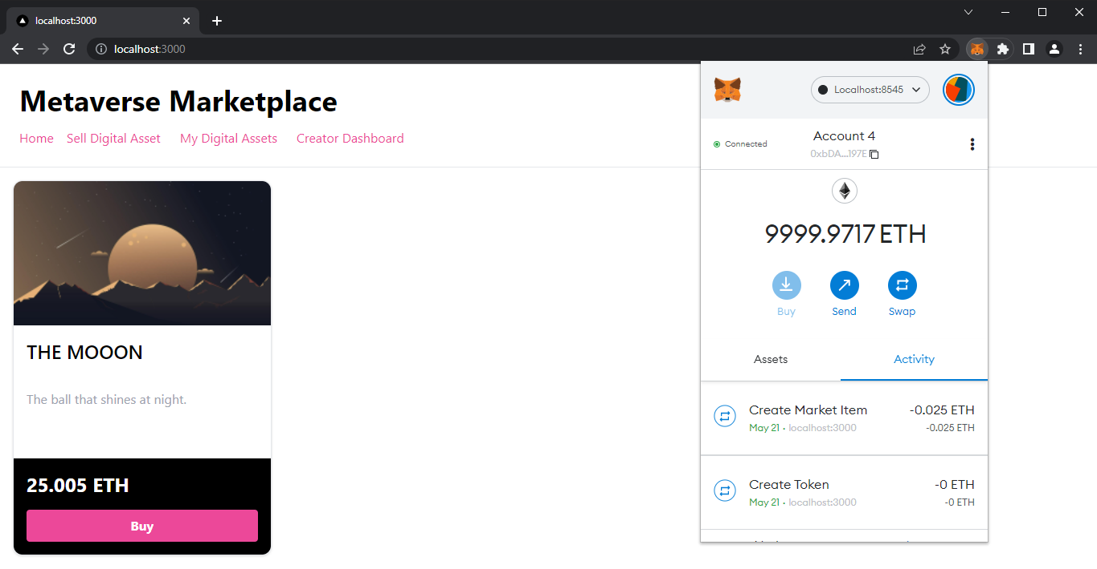

Now we will switch over to other account that will act as a buyer (Account 5)

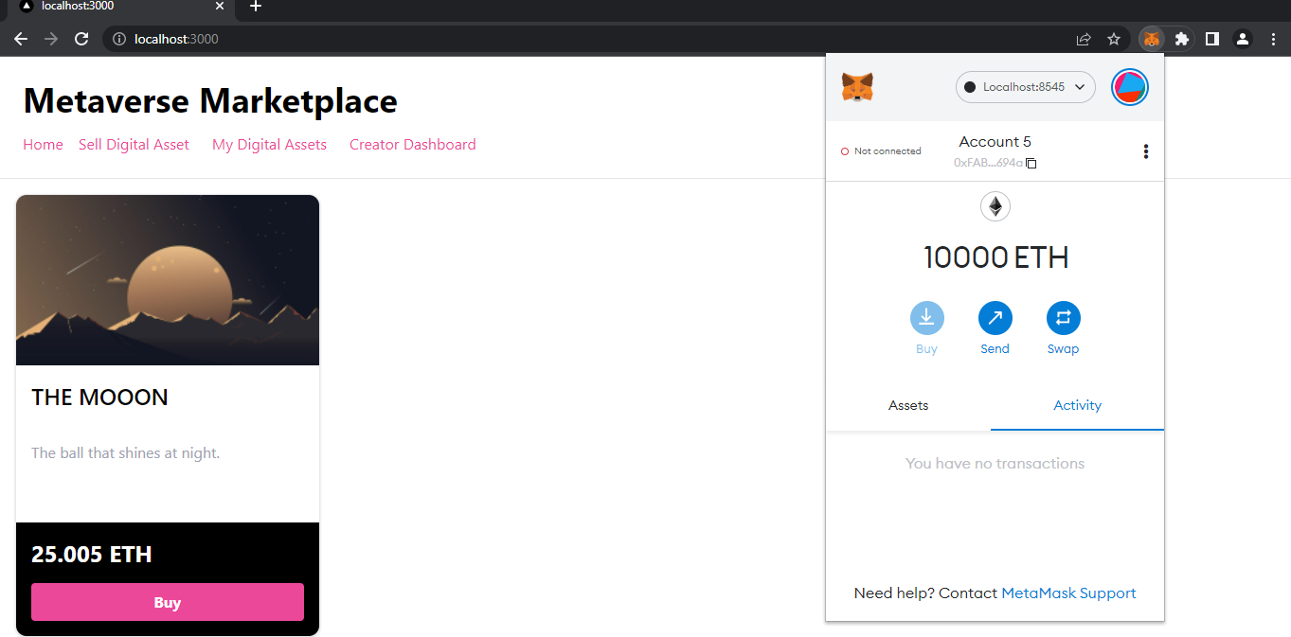

#### **3.4.4 Buying asset**

Buying the digital art (NFT) with Account 5

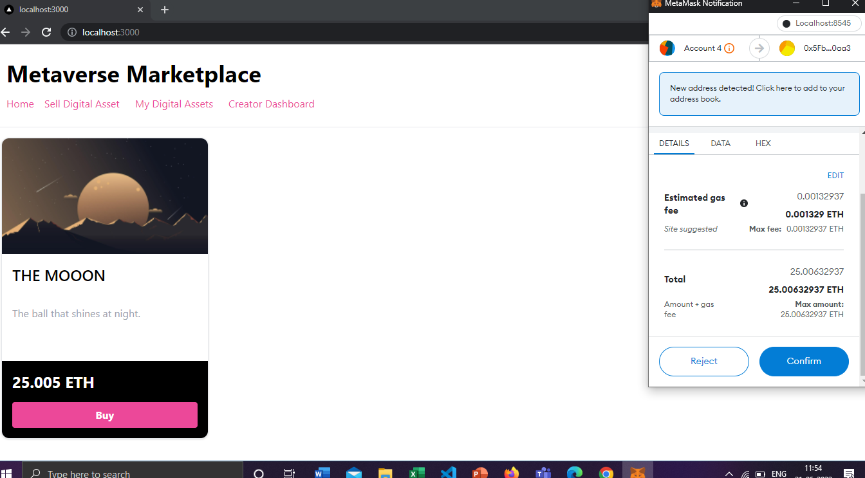

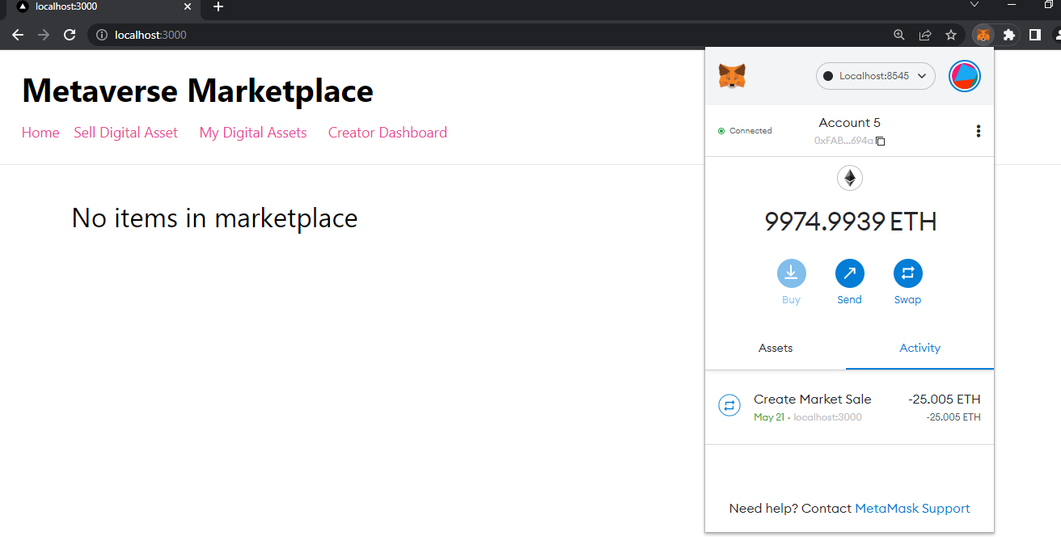

#### **3.4.5 Creator dashboard**

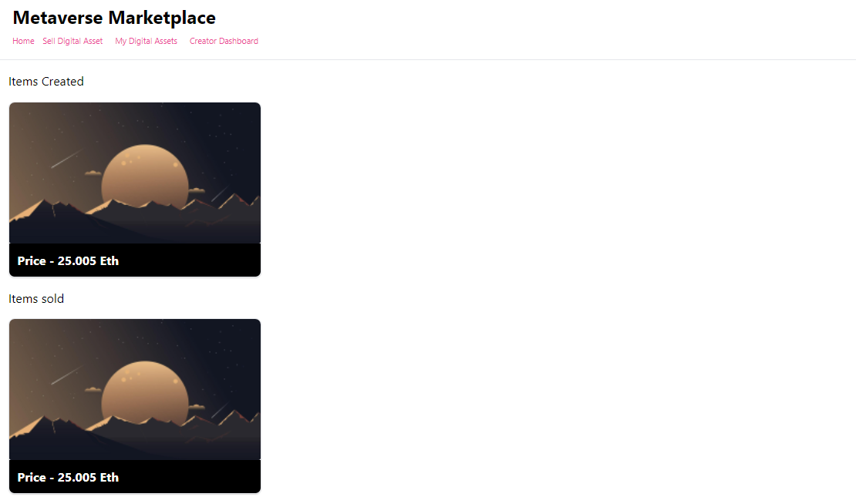

So finally by observing the below pictures we can say that the transaction has successfully completed.

List of transactions that occurred

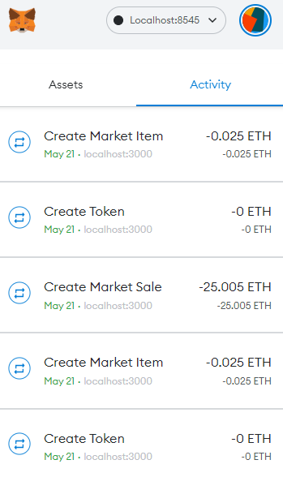

Finally the amount is credited to the sellers account.

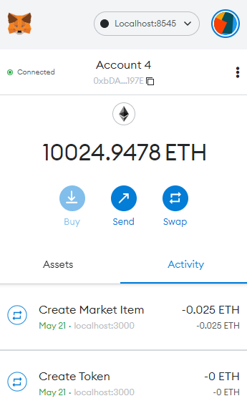

### 

### **3.6 REFERENCES**

◦<https://screenrant.com/expensive-nfts-sold-so-far/>

◦<https://opensea.io/>

◦<https://ethereum.org/en/nft/>

◦<https://ethereum.org/en/developers/docs/smart-contracts/>

◦<https://www.investopedia.com/web-20-web-30-5208698>

◦<https://polygon.technology/>